**Enumerated Datatypes and Typedefs assignments**

1. WAP to define an enum to store designations in an organization. List of possible values are

{E2F=1, E2, E3, E4, E5} Prompt and read a designation from the user. Then display his designation string such as

Designation -Designation String

E2F -Software Fresher

E2 -Software Engineer

E3 -Senior Software Engineer

E4 -Team Lead

E5 -Senior Team Lead

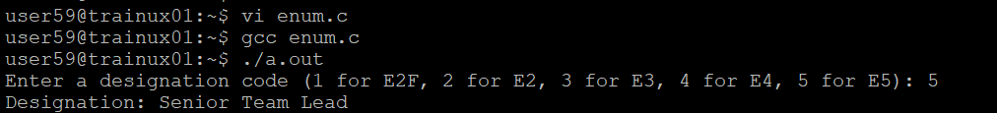

2. Define a typedef structure to keep the configuration of putty server. Identify and place all the required members. Create a structure variable and initialize it with user defined values and finally display the contents.

* **Enum for Designations**: We defined an enum to represent various designations in an organization and displayed the corresponding designation name based on user input.
* **Putty Server Configuration**: We used a typedef structure to store and initialize the configuration of a Putty server, and then displayed the configuration.
* **PuttyConfig Structure**: This structure is used to store the configuration for the Putty server, with fields for the IP address, port, username, password, and session name.
* **scanf**: We use scanf to get input from the user for the server configuration details.
* **printf**: After the input is collected, we print out the configuration.